Cross-Line Internal Rhyme

🔄 What is Cross-Line Internal Rhyme
# Source: Chatgpt (GPT-4-turbo) at [8/2/2025]
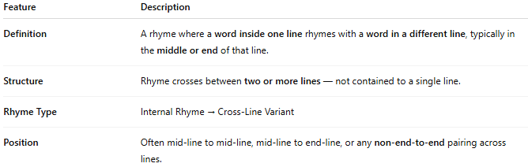
Feature | Description
Definition | A rhyme where a word inside one line rhymes with a word in a different line, typically in the middle or end of that line.
Structure | Rhyme crosses between two or more lines — not contained to a single line.
Rhyme Type | Internal Rhyme → Cross-Line Variant
Position | Often mid-line to mid-line, mid-line to end-line, or any non-end-to-end pairing across lines.

📝 Examples:
# Source: Chatgpt (GPT-4-turbo) at [8/2/2025]
She sang a song of shadows deep,
Where silence hung and dared to creep.
The moonlight poured into his eyes,
As memories soared and echoed cries.
Here, song–hung and poured–soared are internal rhymes across lines.

🎭 Effect in Poetry:
# Source: Chatgpt (GPT-4-turbo) at [8/2/2025]
- Links two lines rhythmically
- Adds cohesion and musical flow
- Enhances imagery or emotional continuity
- Useful in ballads, lyrics, and free verse

✅ When to Use:
# Source: Chatgpt (GPT-4-turbo) at [8/2/2025]
- To maintain sound symmetry across longer or enjambed lines
- For a more subtle rhyme scheme than end rhymes
- When exploring lyrical repetition without formal structure

